1. **INTRODUCTION**

The Stick-IT model is a multi-degree of freedom system consisting of a series of lumped masses connected in series by means of nonlinear shear link elements (Figure 1) that allows the prediction of the nonlinear building response in terms of Interstory Drift Ratios and Peak Floor Accelerations. Based on the analysis of a large database of Gravity load-designed buildings, Gaetani d’Aragona et al.(2020) have suitably calibrated the nonlinear shear springs (envelope curves and hysteretic rules) of the Stick-IT model to simulate the behavior of infilled RC building typologies. The model has been demonstrated to efficiently describe the nonlinear behavior and failure modes in multistory buildings properly capturing the damage concentration and evolution in each story under earthquake loadings.

The adoption of the typological Stick-IT model is proposed to represent RC infilled frame building typologies of assigned storey number and dimensions in plan at the large scale. It can be defined as a function of few geometric and mechanical parameters, namely the in-plan building dimensions, the infills opening percentage and the infill elastic shear modulus. Most of such parameters can be easily retrieved for large scale studies, e.g. from rapid on-site surveys or remote sensing procedures.

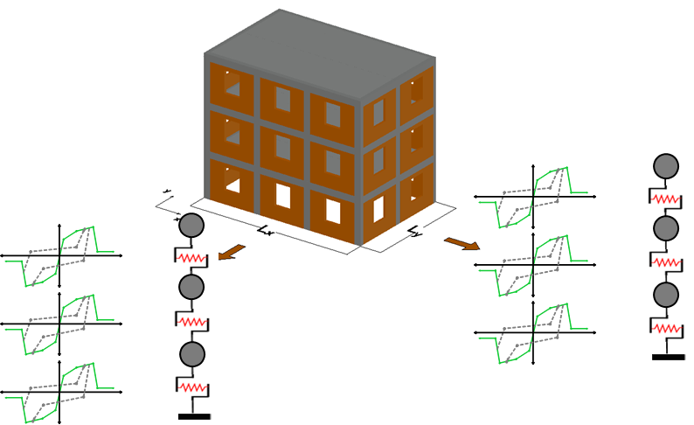

**Figure 1**: Stick-IT model

In this document, an example of the application for the proposed Stick-IT model is presented. A case-study building, damaged during the 2009 L’Aquila earthquake, is adopted as a reference building to show the step-by-step construction and the application of the proposed methodology. For further details about the selected building, please refer to Gaetani d’Aragona et al. 2021.

1. **The Stick-IT formulation**

In Gaetani d’Aragona et al.(2020)the RC infilled frames building typologies are defined based on few geometric and mechanical data that can be easily retrieved via rapid on-site surveys or remote sensing procedures, namely the dimension of the building in the analyzed direction LX or LY, the story number ntot, the percentage of openings in the infills op and Gw.

The model parameters for envelope curves are expressed with an exponential type formulation as in Eq. (1), that expresses the generic parameter Pb,i of the backbone curve at the ith storey:

 (1)

In Eq. (1) L is the dimension of the building in the analyzed direction (L=Lx or Ly depending if longitudinal or transversal direction is considered), nnsi(=i/ns) is the normalized storey number for the generic ith level and op is the percentage of openings in the infills.



**Figure 2**: Definition of Stick-IT parameters

The coefficients to be used in Eq. (1) for each model parameter were calibrated based on a regression study performed on a large database of stick models, consisting of more than 2800 building realizations generated via a simulated design procedure. The following assumptions were adopted for the stick models database generation: a) buildings are regular both in plan and in elevation; b) approximately rectangular shape in plan (the response is analyzed in the two separate directions); c) constant inter-story height (for the database generation it was assumed equal to 3.0m); d) constant span length in each direction and e) uniform infills opening percentage along the height. The database was generated adopting typical features of existing RC buildings in Italy and accounting for possible variabilities in structural and mechanical characteristics within each building typology. For example, for a given surface area (equal to the product LX∙LY) and in-plane aspect ratio LX/LY, a number of possible structural configurations (i.e., different span length and number) were considered and also the material properties for concrete, steel and infills consistency were varied according to assigned probability distributions.

Table 1 reports the coefficients for each parameter, as well as the coefficient of determination R2 resulting from regression analysis. The last two columns in the table report the statistics, median and CoV (%), of the ratio of the effective backbone parameter value to the one calculated with Eq. (1).

**Table 1**. Coefficients to derive the parameters of backbone curve at the generic storey with Eq. (1) and statistics of effective-to-predicted values (Gaetani d’Aragona et al. 2020).

|  |  |  |  |  |  |  |  |  |  |
| --- | --- | --- | --- | --- | --- | --- | --- | --- | --- |
|  | *coefficients* | | | | | | *R2* | *Pb,i/Pb,i,Eq(1)* | |
| Pb,i | a1 | a2 | a3 | a4 | a5 | a6 |  | ❍ | CoV (%) |
| K1 | -3.6∙105 | 920.0 | 0.95 | 0.69 | 1.47 | -0.08 | 0.94 | 0.98 | 17.6 |
| K2 | -8.85∙104 | 1.25•103 | 0.97 | 0.44 | 1.49 | -0.05 | 0.92 | 1.03 | 20.1 |
| |K3| | -1.18∙104 | 27.0 | 0.82 | 0.76 | 1.68 | 0.04 | 0.96 | 1.07 | 18.5 |
| K4 | -4.60∙104 | 87.0 | 0.68 | 0.92 | 2.0 | 0.16 | 0.86 | 0.98 | 29.1 |
| Fcr | -310.0 | 0.74 | 0.96 | 0.69 | 1.47 | -0.08 | 0.94 | 1.04 | 17.1 |
| Fmax | -730.0 | 8.6 | 1.07 | 0.39 | 1.13 | -0.23 | 0.82 | 0.98 | 27.9 |
| log(Fu) | -0.12 | 2.35 | 0.31 | - | - | -0.11 | 0.68 | 0.99 | 8.38 |

Hence, given a building typology, the Stick-IT model is conceived so to allow taking into account the variability of possible structural/mechanical configurations within the typology, by means of a probabilistic characterization of the model parameters. To this end, the model parameters are given in terms of median and CoV (see Table 1), towards probabilistic definition of the Stick-IT model (i.e. model parameter distributions are assigned).

Concerning the hysteretic rules, the Stick-IT was conceived to be applied adopting the Pinching4 material implemented in the Finite Element software OpenSees. The hysteretic rules for Stick-IT model were calibrated to simulate the nonlinear behavior of interstory shear springs in terms of stiffness and strength deterioration, independently from geometrical and mechanical features of the building typology. Assuming that the pinched behavior is symmetric in both the positive and the negative direction the parameters governing pinching response are reduced to 3: P1, P2 and P3. Also, it is assumed that the deterioration only depends on the energy-dependent terms, calculating the stiffness deterioration index as a function of the number of hysteretic cycles (ncyc) and considering suitable deterioration indexes for stiffness gK2 and gK4 and reloading stiffness gD2 and gD4. As example, Eq. (2) expresses the stiffness deterioration index (*δki*) as a function of ncyc depending on two parameters gK2 and gK4:

 (2)

Similar expression can be adopted for deterioration of reloading stiffness.

The parameters to represent the lognormal distributions of the hysteretic parameters are resumed in Table 2. gKlim and gDlim are assumed equal to 3.

**Table 2**. Distribution of pinching parameters and deterioration indexes (Gaetani d’Aragona et al. 2020).

|  |  |  |  |
| --- | --- | --- | --- |
| Parameter | Function (lognormal) | μ | β |
| P1 | f(x) | -0.79 | 0.10 |
| P2 | f(x) | -1.02 | 0.10 |
| P3 | f '(x)=0.25+f (x) | -1.84* | 0.25* |
| gK2 | f(x) | -2.63 | 0.21 |
| gK4 | f(x) | -0.49 | 0.09 |
| gD2 | f(x) | -1.10 | 0.09 |
| gD4 | f '(x)=0.25-f (x) | -2.37* | 0.42* |

* these values represent the parameters ( μ’, β’) of the complementary distribution function

Note that a complementary distribution function is introduced for both P3 and gD4. The lognormal mean μ, and the lognormal standard deviation β, refer to the complementary distribution function (μ’, β’). More details on the model can be found in Gaetani d’Aragona et al. 2020.

1. **EXAMPLE OF APPLICATION**

The reference building is a four-story (three storeys + roof) building located in L’Aquila designed in 1977 and built at the beginning of ‘80s. The building suffered severe structural damage due to the 2009 L’Aquila earthquake. Figure 3 shows the 3D perspective view. For further details refer to Gaetani d’Aragona et al. (2021).

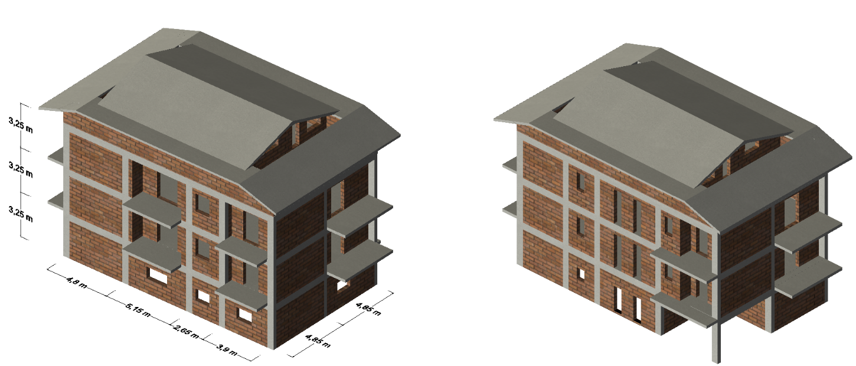

X

Y

1. (b)

**Figure 3**. Reference building (a) NW and (b) SE views (adapted from Gaetani d’Aragona et al. 2021).

Because the upper story of the building has a reduced in plan surface and the presence of an inclined RC roof makes this part of the building significantly rigid with respect to the remaining part of the structure, the upper story is modeled as an equivalent mass assuming rigid behavior; therefore a 3 story model is built.

In order to derive the Stick-IT model, the parameters reported in Table 3 need to be calculated:

**Table 3**. Input parameter for Stick-IT definition

|  |  |  |
| --- | --- | --- |
| Parameter | value |  |
| ntot | 3 | - |
| LX | 17.0 | m |
| LY | 10.0 | m |
| Gw | 1620 | MPa |
| aop | 0.2 | - |

The total number of storeys (ntot) and the plan dimensions (LX, LY) can be generally retrieved based on on-site surveys or remote sensing procedures, while the opening percentage (aop) and the masonry shear modulus (Gw) can be derived based on regional considerations (e.g., construction practices). In this example, the parameters are calibrated on the specific building.

* 1. **BACKBONE CHARACTERIZATION**

In this section, the backbone curve construction procedure and the characterization of the hysteretic behavior of the Stick-IT model is introduced.

Based on the parameters reported in Table 3, the Stick-IT model parameters can be rapidly retrieved by means of Eqs.(1)-(2). In the perspective of a probabilistic approach, the variability of possible structural/mechanical configurations within the typology, can be also introduced.

In particular, to account for potential model variability within the typology corresponding to the reference building, it was decided to generate three different Stick-IT models: 1) a median model (SIT-M) employing median values of parameters; 2) a lower-bound (SIT-LB) model employing parameters corresponding to the 16th percentile of the model parameters distribution and 3) an upper-bound (SIT-UB) model employing parameters corresponding to the 84th percentile of the model parameters distribution.

Firstly, based on Eq.(1) and Table 1, the *storey* backbone curves of the Stick-IT model can be constructed adopting the following explicit equations:

 (3)

 (4)

 (5)

 (6)

 (7)

 (8)

 (9)

For the longitudinal direction, the backbone parameters calculated according to Eqs.(3)-(9) are reported for each story in Table 4.

**Table 4**. Storey backbone parameters according to Eqs.(3)-(9).

|  |  |  |  |  |  |  |  |  |  |  |  |
| --- | --- | --- | --- | --- | --- | --- | --- | --- | --- | --- | --- |
|  | *Input parameters* | | | | *Storey backbone parameters* | | | | | | |
| story | nnsi | L=LX | aop | Gw | K1 | K2 | |K3| | K4 | Fcr | Fmax | Fu |
|  | (-) | (m) | (-) | (MPa) | (kN/m) | (kN/m) | (kN/m) | (kN/m) | (kN) | (kN) | (kN) |
| 1 | 0.33 | 17.0 | 0.2 | 1620 | 1389813.0 | 293525.4 | 38050.5 | 151969.2 | 1137.9 | 2454.3 | 524.5 |
| 2 | 0.67 | 17.0 | 0.2 | 1620 | 1295424.0 | 280512.2 | 39452.0 | 233970.8 | 1059.8 | 1985.1 | 328.3 |
| 3 | 1.00 | 17.0 | 0.2 | 1620 | 1242588.2 | 273106.4 | 40290.0 | 296892.8 | 1016.1 | 1743.3 | 253.7 |

In order to account for the possible variability within the typology, the parameters reported in Table 4 need to be transformed in the corresponding percentile values (50th, 16th, 84th percentiles). By assuming a normal distribution for the backbone parameters, each of the above mentioned formulations can be transformed in order to obtain the corresponding percentile values:

 (10)

where is the inverse of the normal cumulative distribution function with median equal to m and with standard deviation s = CoV(%)/100 ∙ m. Both m and CoV(%) are reported in Table 1.

In table 5 the values of the inverse normal cumulative distribution function for the different parameters K1, K2, K3, K4, Fcr, Fmax, Fu are calculated by adopting the effective-to-predicted and Coefficient of Variation statistics reported in Table 1.

**Table 5**. Values of inverse cumulative distribution function for different backbone parameters.

|  |  |  |  |  |  |  |  |
| --- | --- | --- | --- | --- | --- | --- | --- |
| Percentiles | Φ-1K1 | Φ-1K2 | Φ-1K3 | Φ-1K4 | Φ-1Fcr | Φ-1Fmax | Φ-1Fmin |
| 50th | 0.98 | 1.03 | 1.07 | 0.98 | 1.04 | 0.98 | 0.96 |
| 16th | 0.81 | 0.82 | 0.87 | 0.70 | 0.86 | 0.71 | 0.36 |
| 84th | 1.15 | 1.24 | 1.27 | 1.26 | 1.22 | 1.25 | 1.56 |

By adopting Eq.(10), the backbone parameters can be transformed in the transformed to represent the median (SIT-M), the lower bound (SIT-LB) and the upper bound (SIT-UB) models. The backbone parameters generated accounting for the variability in backbone parameters are reported in Table 6-7-8.

**Table 6**. Backbone parameters for the SIT-M model.

|  |  |  |  |  |  |  |  |
| --- | --- | --- | --- | --- | --- | --- | --- |
|  | *Storey backbone parameters for SIT-M* | | | | | | |
| storey | K1 | K2 | |K3| | K4 | Fcr | Fmax | Fu |
|  | (kN/m) | (kN/m) | (kN/m) | (kN/m) | (kN) | (kN) | (kN) |
| 1 | 1362016.8 | 302331.1 | 40714.0 | 148929.8 | 1183.4 | 2405.3 | 503.5 |
| 2 | 1269515.5 | 288927.6 | 42213.6 | 229291.3 | 1102.2 | 1945.4 | 315.2 |
| 3 | 1217736.4 | 281299.6 | 43110.3 | 290954.9 | 1056.7 | 1708.5 | 243.5 |

**Table 7**. Backbone parameters for the SIT-LB model.

|  |  |  |  |  |  |  |  |
| --- | --- | --- | --- | --- | --- | --- | --- |
|  | *Storey backbone parameters for SIT-LB* | | | | | | |
| storey | K1 | K2 | |K3| | K4 | Fcr | Fmax | Fu |
|  | (kN/m) | (kN/m) | (kN/m) | (kN/m) | (kN) | (kN) | (kN) |
| 1 | 1123630.3 | 241899.4 | 33223.7 | 168264.2 | 982.2 | 1737.9 | 189.6 |
| 2 | 1047319.1 | 231175.0 | 34447.4 | 191756.7 | 914.8 | 1405.6 | 118.7 |
| 3 | 1004602.6 | 225071.8 | 35179.1 | 206756.3 | 877.0 | 1234.4 | 91.7 |

**Table 8**. Backbone parameters for the SIT-UB model.

|  |  |  |  |  |  |  |  |
| --- | --- | --- | --- | --- | --- | --- | --- |
|  | *Storey backbone parameters for SIT-UB* | | | | | | |
| storey | K1 | K2 | |K3| | K4 | Fcr | Fmax | Fu |
|  | (kN/m) | (kN/m) | (kN/m) | (kN/m) | (kN) | (kN) | (kN) |
| 1 | 1600403.2 | 362762.9 | 48204.4 | 114055.7 | 1384.7 | 3072.6 | 817.5 |
| 2 | 1491711.9 | 346680.1 | 49979.9 | 250087.5 | 1289.6 | 2485.1 | 511.7 |
| 3 | 1430870.3 | 337527.5 | 51041.5 | 375153.5 | 1236.4 | 2182.5 | 395.3 |

To implement the story backbone curve in the Pinching4 material, the displacement values corresponding to points P1, P2, P3 and P4 (Figure 4) have to be calculated starting from stiffnesses (K1, K2, K3, K4) and Forces (Fcr, Fmax, Fu):

 (11)

 (12)

 (13)

 (14)

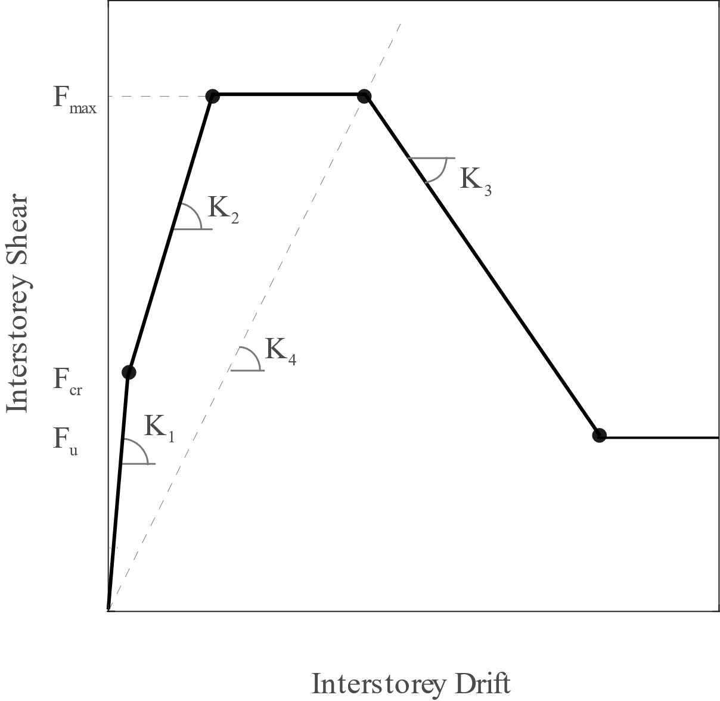

**P1**

**ΔP1**

**ΔP4**

**ΔP3**

**ΔP2**

**P4**

**P3**

**P2**

**Figure 4**. Stick-IT story backbone (adapted from Gaetani d’Aragona et al. 2020)

By adopting Eqs.(11)-(14), Pinching4 backbone parameters can be derived for the SIT-M, the SIT-LB and the SIT-UB models (see Tables 9-11).

**Table 9**. Pinching4 backbone parameters for the SIT-UB model.

|  |  |  |  |  |  |  |  |
| --- | --- | --- | --- | --- | --- | --- | --- |
|  | *Pinching4 backbone for SIT-M* | | | | | | |
| story | D1 | D2 | D3 | D4 | Fcr | Fmax | Fu |
|  | (m) | (m) | (m) | (m) | (kN) | (kN) | (kN) |
| 1 | 0.0009 | 0.0049 | 0.0162 | 0.0629 | 1183.4 | 2405.3 | 503.5 |
| 2 | 0.0009 | 0.0038 | 0.0085 | 0.0471 | 1102.2 | 1945.4 | 315.2 |
| 3 | 0.0009 | 0.0032 | 0.0059 | 0.0399 | 1056.7 | 1708.5 | 243.5 |

**Table 10**. Pinching4 backbone parameters for the SIT-UB model.

|  |  |  |  |  |  |  |  |
| --- | --- | --- | --- | --- | --- | --- | --- |
|  | *Pinching4 backbone for SIT-LB* | | | | | | |
| story | D1 | D2 | D3 | D4 | Fcr | Fmax | Fu |
|  | (m) | (m) | (m) | (m) | (kN) | (kN) | (kN) |
| 1 | 0.0009 | 0.0040 | 0.0103 | 0.0569 | 982.2 | 1737.9 | 189.6 |
| 2 | 0.0009 | 0.0030 | 0.0073 | 0.0447 | 914.8 | 1405.6 | 118.7 |
| 3 | 0.0009 | 0.0025 | 0.0060 | 0.0385 | 877.0 | 1234.4 | 91.7 |

**Table 11**. Pinching4 backbone parameters for the SIT-UB model.

|  |  |  |  |  |  |  |  |
| --- | --- | --- | --- | --- | --- | --- | --- |
|  | *Pinching4 backbone for SIT-UB* | | | | | | |
| story | D1 | D2 | D3 | D4 | Fcr | Fmax | Fu |
|  | (m) | (m) | (m) | (m) | (kN) | (kN) | (kN) |
| 1 | 0.0009 | 0.0055 | 0.0269 | 0.0737 | 1384.6645 | 3072.6 | 817.5 |
| 2 | 0.0009 | 0.0043 | 0.0099 | 0.0494 | 1289.6241 | 2485.1 | 511.7 |
| 3 | 0.0009 | 0.0037 | 0.0058 | 0.0408 | 1236.4236 | 2182.5 | 395.3 |

* 1. **HYSTERETIC BEHAVIOR**

The hysteretic rules for Stick-IT model were calibrated to simulate the nonlinear behavior of interstory shear springs in terms of stiffness and strength deterioration, independently from geometrical and mechanical features of the building typology. In this example, the variability of hysteretic parameters is not considered, and only median values are adopted starting from Table 12:

**Table 12**. Adopted Pinching 4 parameters.

|  |  |  |  |  |  |  |  |  |
| --- | --- | --- | --- | --- | --- | --- | --- | --- |
| P1 | P2 | P3 | gK2 | gK4 | gKlim | gD2 | gD4 | gDlim |
| 0.4538 | 0.3606 | -0.0912 | 0.0721 | 0.6126 | 3.0 | 0.3329 | 0.1565 | 3.0 |

Note that gK1, gK2, gD1, gD3, gF1, gF2, gF3, gF4 are assumed equal to 0. Further, “cyclic” deterioration with dE=10 is adopted.

If variability in hysteretic parameters need to be considered, parameters can be calculated starting from Table 2 adopting lognormal distributions.

1. **MATLAB CODE**

In this folder, a Matlab code is provided that allows to automatically generate the Stick-IT model. Example code refers to the reference building reported in this document, and further analyzed in Gaetani d’Aragona et al. (2021). The code generates the backbone curve and hysteretic parameters corresponding to the three models (SIT-M, SIT-LB, SIT-UB) and the corresponding OpenSees model (in this example only the X direction is analyzed). Finally it runs two earthquakes recorded during the 2009 L’Aquila earthquake sequence. The ground motion records corresponds to the recording stations AQU () and AQK (), whose distance were 2.07km and 2.21km, respectively, from the building site (see Gaetani d’Aragona et al. 2021).

***Before to run the code*, the user should download the OpenSees executable from the official website (**[**https://opensees.berkeley.edu/**](https://opensees.berkeley.edu/)**) and copy the Matlab files in the same folder, or to insert the OpenSees path.**

**The Matlab code consists of 5 files:**

**Main_file.m** – contains the input definition to generate the Stick-IT model and calls the matlab functions allowing the computation of the Backbone (*BackboneParameters.m*) and Hysteretic (*PinchingParameters.m*) parameters. Main_file.m only requires the definition of the number of storeys, the in plan dimensions, the infill masonry shear modulus, and the opening percentage. Further, requires the percentiles for definition of the backbone parameters and Pinching4 parameters. The example code considers three models corresponding to 50th-16th-84th percentiles. After generating the code, the OpenSees software is called to perform the analyses.

% -------------------------------------------------------------------

% Inputs:

% n_storeys: Number of storeys

% Lx_nx: In plan dimension along X axis (in meters)

% Ly_ny: In plan dimension along Y axis (in meters)

% Gw_sym: Shear modulus for infill panels (in MPa)

% alphaOP_sym: Opening percentage for infill panels

% Perctile_B: Percentile adopted while generating Backbone parameters

% Percentile_P: Percentile adopted while generating Pinching4 parameters

**BackboneParameters.m** – Matlab function called by Main_file.m that allows the definition of the backbone curves for different storeys according to §3.1 of the present document. The generated curves, expressed in terms of story displacements and Forces account for the adopted percentiles in the definition of the model (Percentile_B).

**PinchingParameters.m** – Matlab function called by Main_file.m that allows the definition of the hysteretic behavior for the Pinching 4 model, according to §3.2 of the present document. The generated parameters accounts for percentiles in the definition of the hysteretic model (Percentile_P).

**TCL_STICKIT.m** – Matlab function called by Main_file.m that generates the OpenSees Stick-IT models. It generates the following tcl codes, required to define the OpenSees model:

*StickIT_model.tcl* - *TwoNodeLinkGEN.tcl* - Defines the Stick-IT model;

*SpringParameters_median.tcl* – Contains the definition of the backbone curve for the median model (SIT-M) – 50th percentile;

*SpringParameters_LB.tcl* - Contains the definition of the backbone curve for the Lower Bound model (SIT-LB) – 16th percentile;

*SpringParameters_UB.tcl* - Contains the definition of the backbone curve for the Upper Bound model (SIT-UB) – 84th percentile;

Hysteretic_parameters.tcl – Contains the definition of the hysteretic parameters for Pinching4 material;

Analysis_parameters.tcl – Contains information about the ground motion set and the model (if median, LB or UB has to be analyzed)

**PLOT_IDR_PFA_STICK. m** – Matlab function for results post-processing. Elaborates the recording outputs (in /Data) and plot the interstorey drift and the peak floor acceleration profiles.

* 1. **TCL FILES**

Other tcl files are contained in the folder needed to run the analyses (not generated by matlab code):

Stick_analysis_EQ.tcl – represents the main script to run the analyses. Call the scripts generating the model and defining ground motion parameters.

SolutionAlgorithmSubFile.tcl – contains an algorithm allowing convergency;

LibAnalysisDynamicParameters_stick.tcl – defines the dynamic parameters for the analysis;

1. **REFERENCES**

Gaetani d’Aragona M, Polese M, Prota A (2020). Stick-IT: A Simplified Model for Rapid Estimation of IDR and PFA for Existing Low-Rise Symmetric Infilled RC Building Typologies, Engineering Structures, 223, 111182, DOI: 10.1016/j.engstruct.2020.111182.

Gaetani d'Aragona, M., Polese, M., Di Ludovico, M., Prota, A. (2021). The Use of Stick-IT Model for the Prediction of Direct Economic Losses. Earthquake Engineering and Structural Dynamics. Under review.